COURSE NAME: Theory of Computation COURSE CODE: CSA1305

COURSE OUTCOME COVERED

CO1: Apply mathematical foundations such as formal proofs, induction, and basic concepts of automata theory to solve computational problems. (BL:3)

Assessment Tool Weightage: 40%

QUESTIONS: 5 Total Marks:50
Duration: 1 Hour

Analytical Problem

Code of Conduct:

I _K.Vasudeva Reddy(192411256)_ (Name / Reg No) certify that this submission is my original work and that I have adhered to the guidelines specified for this assessment.
I understand that any violation of academic integrity rules will result in disciplinary action.

Signature of the student:

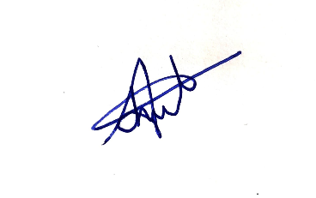

Question 1: Consider the NFA given below which accepts some language L over the alphabet 𝚺={a,b}. Construct a DFA that represents the same language L
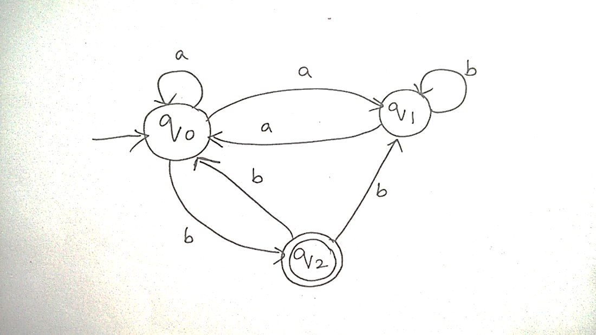

Answers:
Reading the NFA: Start state = v0. Final state = v2 (double circle).
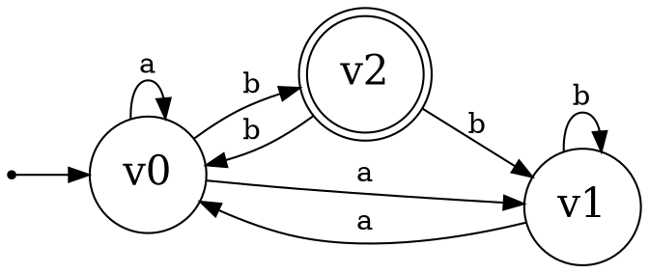
State | a | b
→v0 | {v0, v1} | {v2}
v1 | {v0} | {v1}
*v2 | ∅ | {v0, v1}

Step 1: Subset Construction
Start with A = {v0} and process every new subset until no new subsets appear.
- A = {v0}: δ(A,a) = {v0,v1} = B δ(A,b) = {v2} = C
- B = {v0,v1}: δ(B,a) = δ(v0,a)∪δ(v1,a) = {v0,v1}∪{v0} = {v0,v1} = B δ(B,b) = δ(v0,b)∪δ(v1,b) = {v2}∪{v1} = {v1,v2} = D
- C = {v2}: δ(C,a) = δ(v2,a) = ∅ = F (dead state) δ(C,b) = δ(v2,b) = {v0,v1} = B
- D = {v1,v2}: δ(D,a) = δ(v1,a)∪δ(v2,a) = {v0}∪∅ = {v0} = A δ(D,b) = δ(v1,b)∪δ(v2,b) = {v1}∪{v0,v1} = {v0,v1} = B
- F = ∅ (trap): δ(F,a) = ∅ = F δ(F,b) = ∅ = F
No new subsets appear → construction complete.

Step 2: DFA Transition Table
DFA State | Contains v2? | a | b
→ A = {v0} | No | B | C
B = {v0,v1} | No | B | D
*C = {v2} | Yes | F | B
*D = {v1,v2} | Yes | A | B
F = ∅ | No | F | F

Start state: A.
Final states: C, D (contain v2, the only accepting state of the NFA).
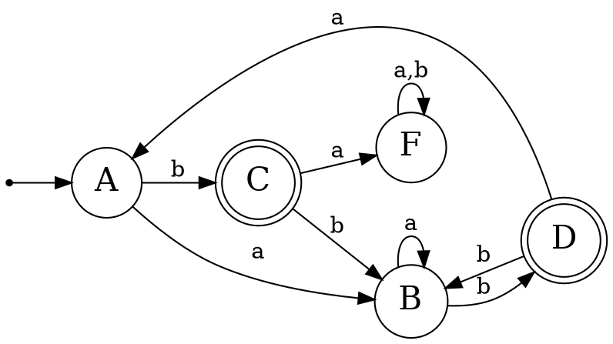

Question 2: Let L be the language of words of length atleast 2 whose last two letters are difference from each other. For example abaab is in L but not bb, Construct an NFA for L, Then draw the equivalent DFA

Answer:
Over Σ = {a,b}, "last two letters different" means the string ends in ab or ba.

Step 1: NFA (guess the second-to-last symbol)
q0 loops on any symbol; nondeterministically guesses the current symbol is second-to-last, moves to q1 (if 'a') or q2 (if 'b'), then checks the next symbol is the opposite letter and lands in qf (final).

State | a | b
→q0 | {q0, q1} | {q0, q2}
q1 | ∅ | {qf}
q2 | {qf} | ∅
*qf | ∅ | ∅

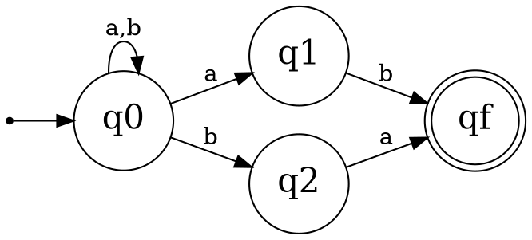

Step 2: Convert to DFA (subset construction)
- S0 = {q0}: a → {q0,q1} = S1 b → {q0,q2} = S2
- S1 = {q0,q1}: a → {q0,q1}∪∅ = S1 b → {q0,q2}∪{qf} = {q0,q2,qf} = S3
- S2 = {q0,q2}: a → {q0,q1}∪{qf} = {q0,q1,qf} = S4 b → {q0,q2}∪∅ = S2
- S3 = {q0,q2,qf}: a → {q0,q1,qf} = S4 b → {q0,q2} = S2
- S4 = {q0,q1,qf}: a → {q0,q1} = S1 b → {q0,q2,qf} = S3

DFA Transition Table
State | Contains qf? | a | b
→ S0 = {q0} | No | S1 | S2
S1 = {q0,q1} | No | S1 | S3
S2 = {q0,q2} | No | S4 | S2
*S3 = {q0,q2,qf} | Yes | S4 | S2
*S4 = {q0,q1,qf} | Yes | S1 | S3

Start = S0, Final = {S3, S4}. Check: "abaab" → S0→a→S1→b→S3→a→S4→a→S1→b→S3 (final ✓). "bb" → S0→b→S2→b→S2 (not final ✓).

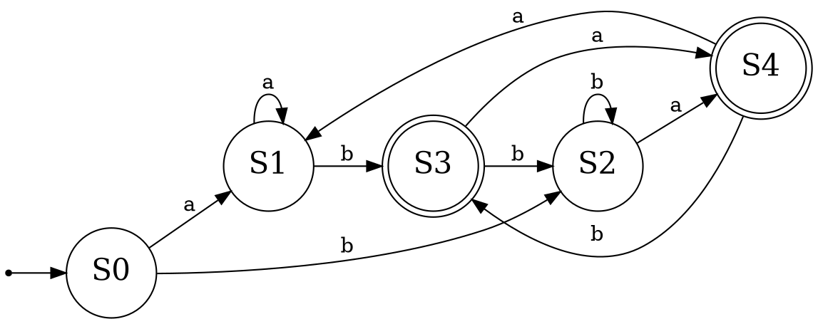

Question 3: Design a Nondeterministic Finite Automata (NFA) that takes a binary string as input and accepts the string only if the last two digits are the same (either 00 or 11). Write the formal definition of the NFA. Also show that the string 01011 is accepted by the NFA

Answer:
Formal definition M = (Q, Σ, δ, q0, F)
- Q = {q0, q1, q2, q3, q4}
- Σ = {0, 1}
- Start state = q0
- F = {q2, q4}

State | 0 | 1
→q0 | {q0, q1} | {q0, q3}
q1 | {q2} | ∅
*q2 | ∅ | ∅
q3 | ∅ | {q4}
*q4 | ∅ | ∅
Logic: q0 loops on any symbol; non deterministically guess the current symbol is second-to-last — go to q1 if it's 0 (expecting one more 0) or q3 if it's 1 (expecting one more 1); q2/q4 are accepting states reached after the matching final symbol.
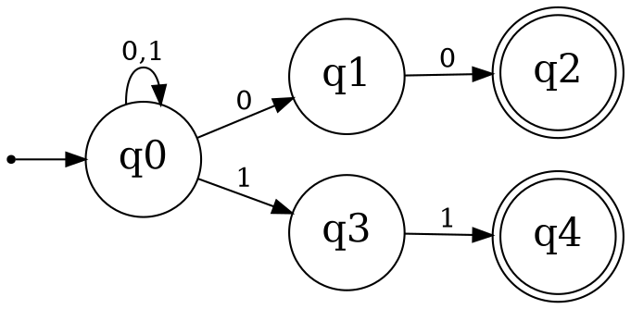

Showing that 01011 is accepted
Trace one accepting path through the NFA (a witness path, since the machine is nondeterministic):
Input read | 0 | 1 | 0 | 1 | 1
Path | q0→q0 | q0→q0 | q0→q0 | q0→q3 | q3→q4

Path: q0 —0→ q0 —1→ q0 —0→ q0 —1→ q3 —1→ q4
Since q4 ∈ F, the string 01011 is accepted — the last two symbols "11" match, so the automaton takes the branch q0→q3 on the 4th symbol and q3→q4 on the 5th symbol.

Question 4: Consider the NFA given below which accepts the language representing the set of all strings having 001 as a substring over the alphabet 𝚺={0,1}. Construct a DFA that represents the same language.

Answer:
Q = {q0,q1,q2,q3} where q0 = haven't matched yet, q1 = seen "0", q2 = seen "00", q3 = "001" seen (final, absorbing).
State | 0 | 1
→q0 | {q0, q1} | {q0}
q1 | {q2} | ∅
q2 | ∅ | {q3}
*q3 | {q3} | {q3}
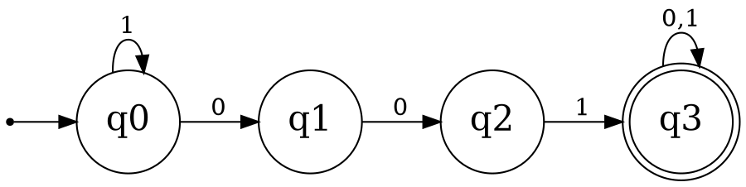

Subset construction
- A = {q0}: 0 → {q0,q1} = B 1 → {q0} = A
- B = {q0,q1}: 0 → {q0,q1}∪{q2} = {q0,q1,q2} = C 1 → {q0} = A
- C = {q0,q1,q2}: 0 → {q0,q1,q2} = C 1 → {q0}∪{q3} = {q0,q3} = D
- D = {q0,q3}: 0 → {q0,q1}∪{q3} = {q0,q1,q3} = E 1 → {q0,q3} = D
- E = {q0,q1,q3}: 0 → {q0,q1}∪{q2}∪{q3} = {q0,q1,q2,q3} = G 1 → {q0,q3} = D
- G = {q0,q1,q2,q3}: 0 → G 1 → D

Full DFA table
State | Contains q3? | 0 | 1
→A={q0} | No | B | A
B={q0,q1} | No | C | A
C={q0,q1,q2} | No | C | D
*D={q0,q3} | Yes | E | D
*E={q0,q1,q3} | Yes | G | D
*G={q0,q1,q2,q3} | Yes | G | D
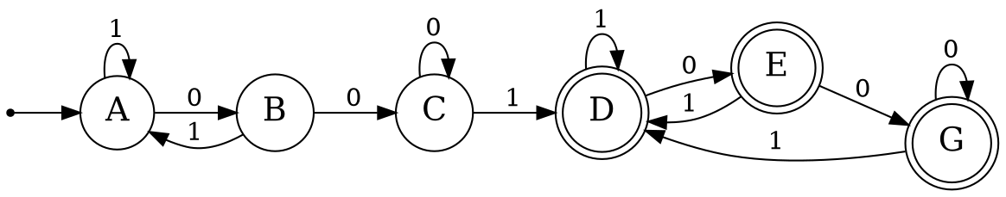

Minimization
Once q3 is included, "001" has already occurred and the string stays accepted forever regardless of what follows. D, E, G therefore all behave identically going forward (all final; transitions stay within {D,E,G}) — merge them into a single accepting trap state T.

State | 0 | 1
→A | B | A
B | C | A
C | C | T
*T | T | T

Interpretation: A = no relevant prefix yet, B = just saw "0", C = just saw "00", T = "001" has occurred (accept forever after).
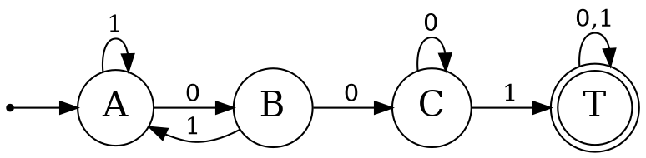

Question 5: A NFA with ε-transitions is given below. Find ε-closure for each state and Design an equivalent DFA which accepts the same language. Draw its transition table and mark the initial and final states
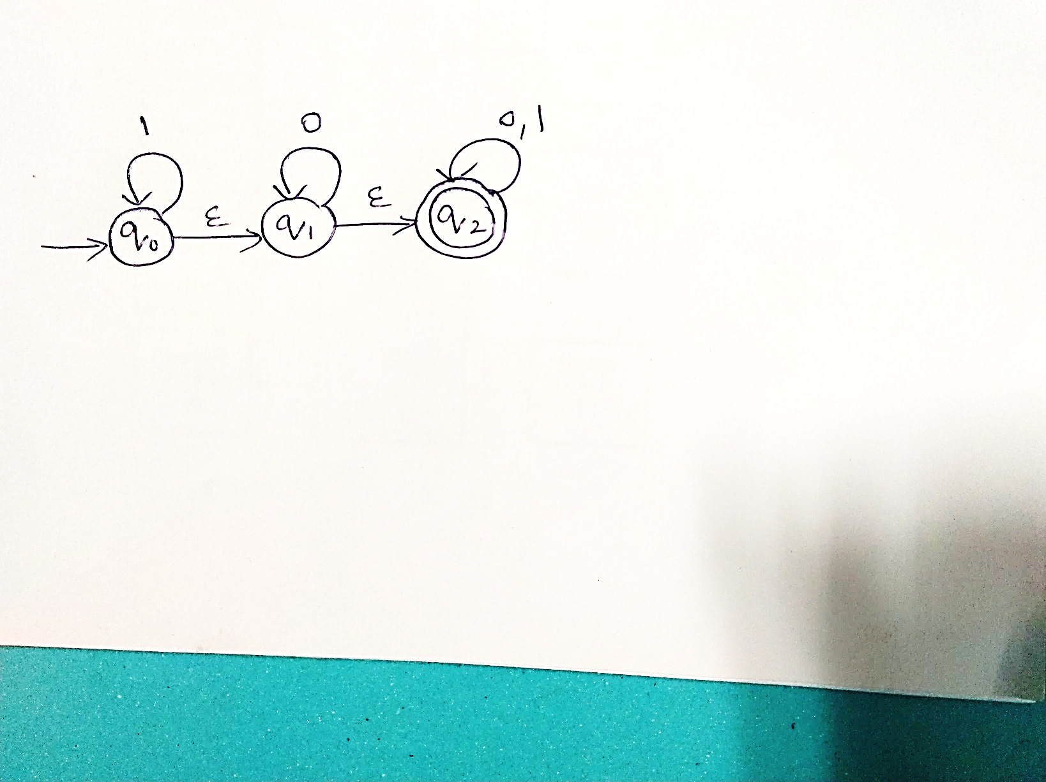

Answer:
The given ε-NFA: Q = {v0, v1, v2}, Σ = {0, 1}, start = v0, F = {v2}

State | 0 | 1 | ε
→v0 | ∅ | {v0} | {v1}
v1 | {v1} | ∅ | {v2}
*v2 | {v2} | {v2} | ∅
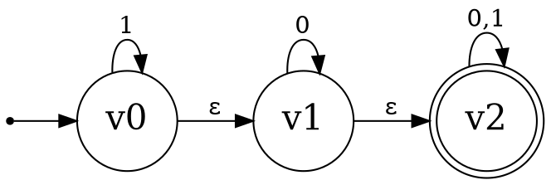

Step 1: ε-closures
The ε-closure of a state is the set of all states reachable using only ε-moves (including the state itself).
- ε-closure(v0) = {v0, v1, v2} (v0 →ε v1 →ε v2)
- ε-closure(v1) = {v1, v2} (v1 →ε v2)
- ε-closure(v2) = {v2} (no outgoing ε-moves)

Step 2: Subset construction using ε-closures
Rule: for a DFA state (set of NFA states) S and input symbol x, δ'(S,x) = ε-closure( ⋃ δ(s,x) for s in S )
Start state of the DFA = ε-closure(v0) = {v0, v1, v2} → call it A
- A = {v0,v1,v2}: 0 → ∅∪{v1}∪{v2} = {v1,v2}, closure = {v1,v2} = B 1 → {v0}∪∅∪{v2} = {v0,v2}, closure = {v0,v1,v2} = A
- B = {v1,v2}: 0 → {v1}∪{v2} = {v1,v2}, closure = B 1 → ∅∪{v2} = {v2}, closure = {v2} = C
- C = {v2}: 0 → {v2}, closure = C 1 → {v2}, closure = C
No new subsets appear → done. Only 3 reachable DFA states: A, B, C.

Step 3: DFA Transition Table
DFA State | NFA states | Final? | 0 | 1
→*A | {v0,v1,v2} | Yes | B | A
*B | {v1,v2} | Yes | B | C
*C | {v2} | Yes | C | C

Initial state: A. Final states: A, B, C — all three, since v2 (the only accepting NFA state) is reachable by ε-moves from every state, including the start state itself.
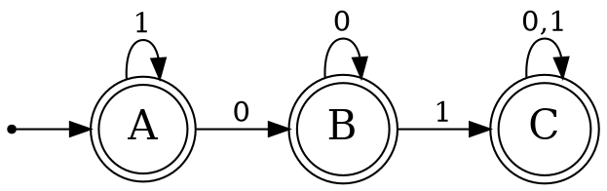
Note on the language: because the start state's ε-closure already contains the final state v2, the empty string is accepted, and since every reachable DFA state is also final, this ε-NFA accepts all strings over {0,1}, i.e. L = Σ* (including ε).

RUBRICS FOR CALCULATION

Criteria | Weightage | Q1 (10) | Q2 (10) | Q3 (10) | Q4 (10) | Q5 (10) | Total Marks (50)
Conceptual Understanding | 30 | 3 | 3 | 3 | 3 | 3 | 15
Accuracy of Answer | 25 | 2.5 | 2.5 | 2.5 | 2.5 | 2.5 | 12.5
Application of Knowledge | 20 | 2 | 2 | 2 | 2 | 2 | 10
Completeness of Response | 15 | 1.5 | 1.5 | 1.5 | 1.5 | 1.5 | 7.5
Clarity & Presentation | 10 | 1 | 1 | 1 | 1 | 1 | 5
Total per Question | 10 Marks | /10 | /10 | /10 | /10 | /10 | / 50

100

